**2023-2024 SCHOOL YEAR**

**LENA WHITMORE ELEMENTARY SCHOOL**

**STUDENT SUPPLIES**

**GRADE ONE**

* 1 backpack LABELED
* 2 boxes 24 count crayons
* 1 package, 8-10 count wide tip markers
* 1 (5 x 8) – inch plastic pencil box
* Thin tip black permanent markers
* 4 low odordry erase markers, black
* 2 large glue sticks or 1 bottle liquid glue
* 1 wide ruled composition notebook
* 2 erasers (larger ones, not end of the pencil type) 
* 1 individual reusable/spill proof water bottle

**Donations for the classroom:**

* 1 box re-closable plastic bags (any size)
* 2 boxes of tissues
* Disinfectant wipes or Hand sanitizer
* 4 class size boxes of individually wrapped snacks (For example crackers, pretzels, granola bars, fruit snacks, popcorn)

**Suggested school supply brands:**

Composition notebooks MEAD

Glue ELMERS

Disinfectant wipes CLOROX

Dry Erase Markers EXPO

Crayons CRAYOLA

Erasers PINK PEARL

Pencils DIXON, TICONDEROGA

***In keeping with our recycling philosophy, students who bring cold lunches are asked to bring reusable containers to further cut down on our disposable garbage. Thank you.***

**2023-2024 SCHOOL YEAR**

**LENA WHITMORE ELEMENTARY SCHOOL**

**STUDENT SUPPLIES**

C:\Documents and Settings\sturgesl\Local Settings\Temporary Internet Files\Content.IE5\UW3S2GP4\MC900384132[1].wmf**GRADE TWO**

* 2 bottom pocket folders
* 1 package of colored pencils
* 1 box crayons, 24ct.
* 1 package of water-based markers
* 1 pencil box
* 2 erasers (larger ones, not end of the pencil type)
* 3 glue sticks
* 1 primary composition books

(pages of book have top half for illustrations and bottom half with penmanship lines for writing)

* 1 spiral notebook
* 24 pack #2 pencils (wood only)
* 1 individual reusable/spill proof water bottle

Donations for the classroom:

* 1 containers disinfectant wipes
* 2 tissue boxes

***In keeping with our recycling philosophy, students who bring cold lunches are asked to bring reusable containers to further cut down on our disposable garbage. Thank you.***

**2023-2024 SCHOOL YEAR**

**LENA WHITMORE ELEMENTARY SCHOOL**

**STUDENT SUPPLIES**

**GRADE THREE**

Labels will be provided at Back to School Night

* 2 bottom pocket folders
* 1 zippered pencil pouch
* 2 erasers (larger ones, not end of the pencil type)
* 2 black/white composition book (wide ruled)
* 1 spiral notebook (wide ruled)
* 1 box of 24 ct. crayons
* 1 pkg colored pencils
* 1 pkg markers
* 2 glue sticks
* 1 scissor
* Sharpie marker, black
* 1 individual reusable/spill proof water bottle

Donations for the classroom:

* 2 boxes of snack crackers
* 1 box tissues
* 1 container disinfecting wipes

***In keeping with our recycling philosophy, students who bring cold lunches are asked to bring reusable containers to further cut down on our disposable garbage. Thank you.***

**2023-2024 SCHOOL YEAR**

**LENA WHITMORE ELEMENTARY SCHOOL**

**STUDENT SUPPLIES**

**GRADE FOUR**

***All paper items should be WIDE ruled if possible***

* #2 pencils
* 1 lined composition book
* 2 spiral notebook
* 5 bottom pocket folders
* washable markers
* 4 low odor, fine tip dry erase markers, black
* colored pencils
* A picture containing toy

  Description automatically generated3 glue sticks
* 1 eraser (larger ones, not end of the pencil type)
* Zippered pencil pouch
* 1 individual reusable/spill proof water bottle

Donations for the classroom:

* **$3.00** donation for student planner notebook
* 1 container disinfecting wipes
* 1 box tissues
* Individually wrapped healthy snacks

***In keeping with our recycling philosophy, students who bring cold lunches are asked to bring reusable containers to further cut down on our disposable garbage. Thank you.***

**2023-2024 SCHOOL YEAR**

**LENA WHITMORE ELEMENTARY SCHOOL**

**STUDENT SUPPLIES**

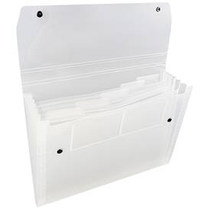**GRADE FIVE**

* 1 box colored pencils
* 2 package #2 pencils (replenish throughout year)
* 6 glue sticks
* 1 pair scissors
* Colored pen(s) for correcting
* 1 calculator (inexpensive)
* 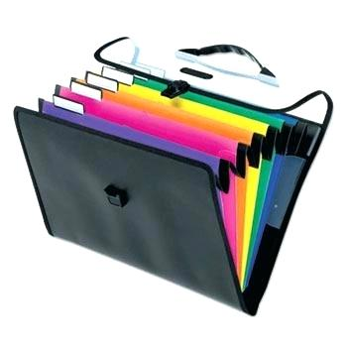1 eraser (larger ones, not end of the pencil type)
* 1 handheld pencil sharpener
* 4 low odor dry erase markers, black
* 1 expandable pocket plastic folder (6-8 compartments)
* 3 spiral notebook
* 1 composition books
* 1 individual reusable/spill proof water bottle

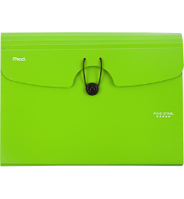

Donations for the classroom:

* **$3.00** donation for student planner notebook
* 1 box tissue
* 1 container of disinfecting wipes

***In keeping with our recycling philosophy, students who bring cold lunches are asked to bring reusable containers to further cut down on our disposable garbage. Thank you.***

**2023-2024 SCHOOL YEAR**

**LENA WHITMORE ELEMENTARY SCHOOL**

**STUDENT SUPPLIES**

**KINDERGARTEN**

* 1 backpack large enough to hold a folder, shoes, snow pants, library book, etc.
* 1 hard plastic pencil box clearly labeled with student’s name **containing the following items**:
  + 4 sharpened (yellow #2) wood pencils
* 6 glue sticks
* 1 – 24 count box of color crayons (removed from packaging)
* 1 box broad tip washable markers – basic colors (removed from packaging)
* MCj02322820000[1]2 black dry erase markers
* 1 – 8 color watercolor paint set
* 1 reusable/spill proof water bottle labeled with student’s name

Donations for the classroom:

* 1 container disinfectant wipes
* 1 box tissue
* 1 box zip-top plastic bags (sandwich OR gallon size)
* 2 large boxes individually wrapped snacks (crackers, cereal, pretzels, goldfish, fruit snacks and/or cheese sticks)

***In keeping with our recycling philosophy, students who bring cold lunches are asked to bring reusable containers to further cut down on our disposable garbage. Thank you.***